(Approx. 1584 words)

Internet Security
By Dick Maybach, Member, Brookdale Computer Users’ Group, NJ
February 2016 issue, BUG Bytes
www.bcug.com
n2nd (at) att.net

In my January 2016 article (available at http://www.bcug.com), I discussed Internet privacy, which in closely related to Internet security. Many of the topics fall into both categories and the choice of the article in which they appear was quite arbitrary.

A personal computer is secure until you connect it to the Internet, which is why the title of this article isn't “Computer Security;” however, without communications, a PC loses much of its value. Yours is almost certainly connected, but you can take steps that greatly reduce the risks. First recognize that the greater risk is not to your computer but to the personal information it holds. We'll consider two types of defense, preventing attacks and recovering from any that do occur.

The most important step you can take is to keep your operating system and your applications up to date. This can be automatic for your operating system, although I prefer to have the vendor tell me when updates are available and decide for myself whether to install them. You will probably have to check each application separately, but this is surely worth the trouble. While you're in a housecleaning mindset, remove all those applications you no longer use, as each one represents a potential vulnerability. Until you've completed this, updating your anti-virus software is wasted effort.

In particular, if you're still using Windows XP, disconnect that PC from the Internet now, and never reconnect it while XP is running. If you must check your e-mail or your bank balance, use a secure operating system, such as Tails, http://tails.boum.org/, on a live DVD or (better) on a memory stick. Tails, which I discussed last month for a slightly different use, includes a nice suite of applications, including an Internet browser, an e-mail client, an office suite, graphics designer software, media players, a screen reader for the visually impaired, and a password manager. While using Tails you can't run any XP software, but you can read and write files on your XP disk. Tails is Linux, but as the screen-shot below shows, its user interface is similar to XP's, and you should feel comfortable using it. (In the shot, Tails has opened an image on the Windows 7 disk of the netbook on which it's running.) Furthermore, since Tails resides on a live medium, you can safely use it from almost any PC, regardless of how insecure it might be. Tails is designed for high security, and it's worth considering for such tasks as Internet banking, even if your present operating system is up to date.

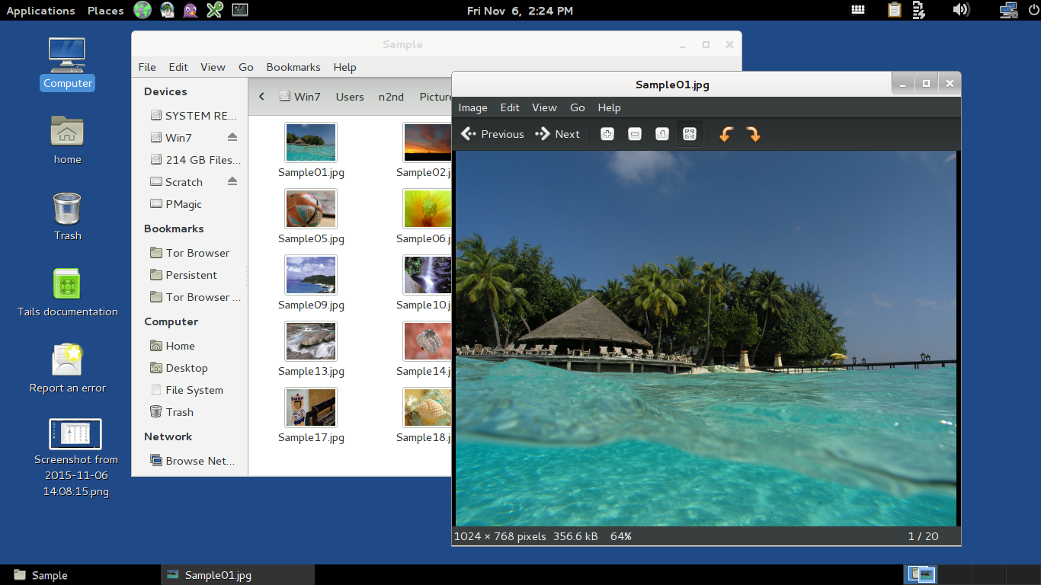
Once your software is updated, you should secure your Internet connection with an effective firewall, which monitors your communication stream and blocks malicious traffic. At the least, install a software firewall on your PC, which many anti-virus suites contain, but a hardware one is more effective. Most broadband modems that include routers also have firewalls, but often ISPs don't keep these updated, with the result that you may prefer to install an Ethernet router that contains a firewall with the latest firmware available from the vendor. Keeping your router and firewall software updated is as important as for your operating system and applications. If your router includes Wi-Fi, be sure you have enabled WPA encryption and changed both the Wi-Fi and the administrator passwords. Otherwise, passersby and your neighbors have free access to your computers and your Internet connection.

Next address the least secure component in your system, yourself. Establish a process to generate secure passwords and store them securely and use it everywhere, and never use the same password for different places. A good application for this is KeePassX, http://www.keepassx.org/, which both generates secure passwords and stores them in an encrypted file. You have no doubt heard that you should never use as a password anything that can be linked to you, such as you mother's maiden name, your college, or a pet's name. Yet your bank insists on recording your answers to “security questions” that have these very things as answers, so that they can be used in case you lose your password. If you follow this irresponsible advice, an intruder looking at your Facebook page can probably find the answers needed to compromise your account. The solution is to use secure “answers” to these silly questions. For example the name of your high school could be x9$Aw*_35{py. You'll of course have to store such obscure answers in your password program.

From my experience, most malware is installed on computers by users tricked by unscrupulous Internet sites. Be very careful when downloading software, as many sites include unwanted extras with the program you want. When making a search, I often find that the official source of an application is far down the list returned, and that the top choices often try to masquerade as the official source. Windows users have to be especially careful, both because Windows is vulnerable to malware and because being the most popular operating system makes it the most attractive target.

E-mail is another risk. The only safe way to deal with a message from someone you don't know is to delete it immediately. Don't open any attachments and don't follow any links. This is good advice even if you think you know the sender, as e-mail addresses are easily forged. Unless you are expecting it, treat any e-mail with an attachment or a link as toxic. This is especially true of forwarded messages, since people in the habit of doing this seldom have the expertise to check them for hazards. Be especially careful of official looking e-mail claiming to be from your bank, the government, Microsoft, or similar entities and demanding immediate attention to avoid serious consequences. These folks seldom use e-mail to sound alarms. If you are concerned, contact them using the phone number or e-mail address you obtained directly from them, not the one in the e-mail.

A common risk is euphemistically known as “social engineering” or “phishing,” but is just swindling using techniques that have been around for thousands of years. You can often recognize these because they are one of the following:
- an unexpected email with a link or an attachment,
- a request that you forward emails, attachments, or links to others,
- a promise too good to be true,
- an email that isn’t addressed to you by name,
- a sender who isn’t specified, isn’t someone you know, or doesn’t match the “from” address,
- one with spelling or grammar errors,
- one with a link that doesn’t match where the email says the link will take you, or an attachment with an incorrect or suspicious filename or a suspicious file extension,
- one with a link or attachment to view an unexpected e-card or track an unknown package, or
- one that includes links to pictures or videos from people you don’t know.

Other common techniques include e-mails or phone calls asking for sensitive information or asking that you perform some task, such as the following:
- a request for your name, account information, date of birth, Social Security number, address, and the like,
- a request that you click on a link or open a file to resolve a problem with your account or to repair a problem with your computer,
- a security alert in an email, pop-ups, or a Facebook notice warning that your computer is at risk of being infected, or
- someone (probably an acquaintance) in another country needing assistance
accessing a large sum of money, or stuck without any money,
- an IRS agent claiming that you owe taxes and must pay immediately.

Anytime you are using the Internet, you should be as cautious as if you were on the street in a foreign country, because you are. It is easy to be lulled into a false sense of security because you are physically sitting in the familiarity of you own home.

You may be surprised that this far into the article, I haven't mentioned anti-virus programs. That's because prevention is far more effective than correction. Relying an anti-virus software as your only defense is like relying only on surgery and drugs to maintain your health; where a good diet, exercise, and sensible personal habits are more effective. However, as with your health, even with good preventive measures, your computer can be compromised, and a common cure for Windows malware is a good anti-virus program. Just keep in mind that these aren't cure-alls, because they can only detect, and often but not always remove, that malware they know about. They can't prevent problems resulting from unpatched software or careless users. The only sure cure is a good backup regimen, which will allow you to recover not only from malware infection, but also hardware and software failure, and user mistakes. There are many anti-malware programs from which to choose, ranging in cost from free upward, and an Internet search will show good reviews of these. Although they're not well rated, I use only the native Windows firewall and Microsoft Security Essentials. I feel that my preventive measures are effective, and I have frequent backups for recovery although I've seldom needed to resort to them. Although you should know that I usually do my Internet browsing from Linux, using Firefox with several protection add-ons enabled.

By making preparations and staying alert you can enjoy the Internet with minimal risk, and if you are attacked, you can recover with little or no loss.

